<https://www.tecmint.com/sshpass-non-interactive-ssh-login-shell-script-ssh-password/>

**sshpass:**

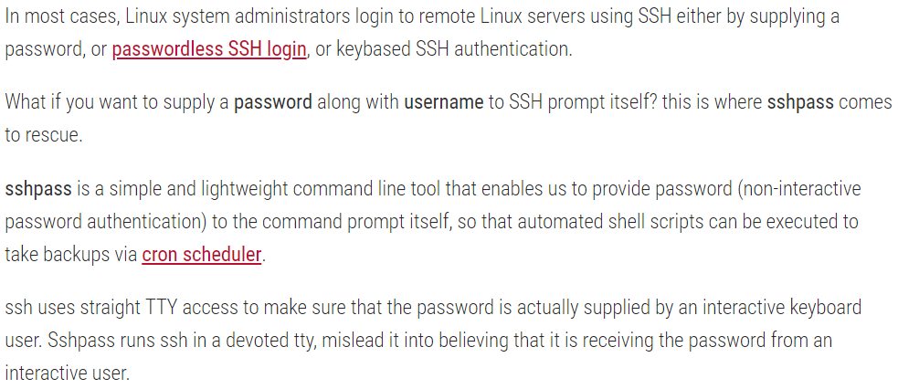



**Installation:**

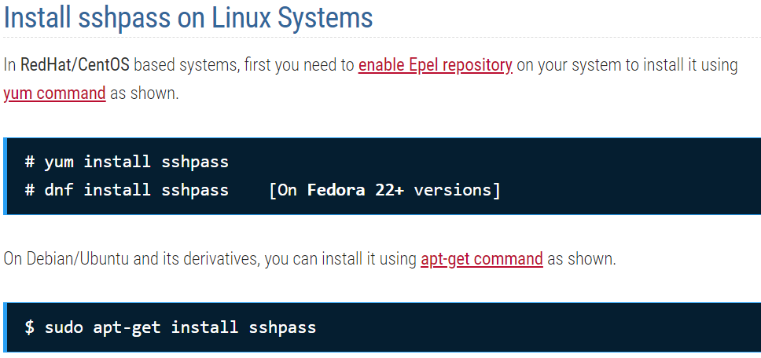

**Usage:**

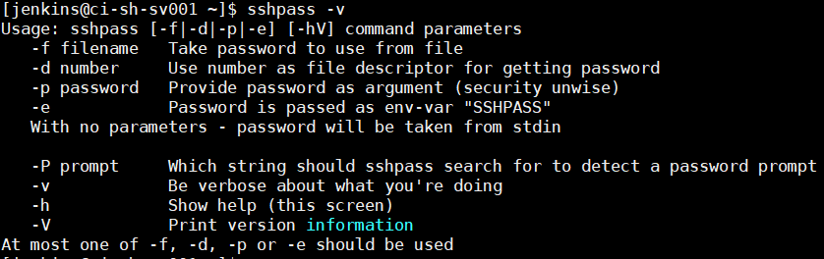

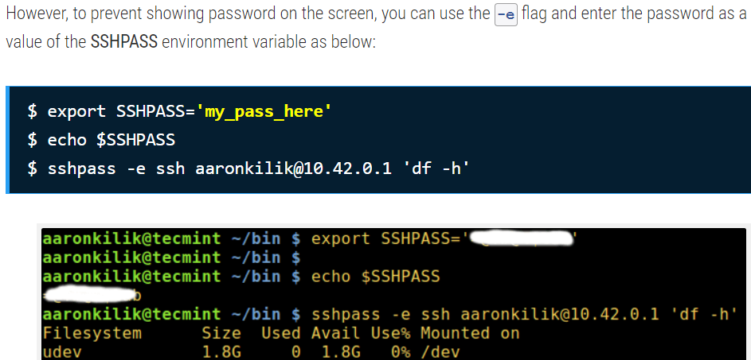

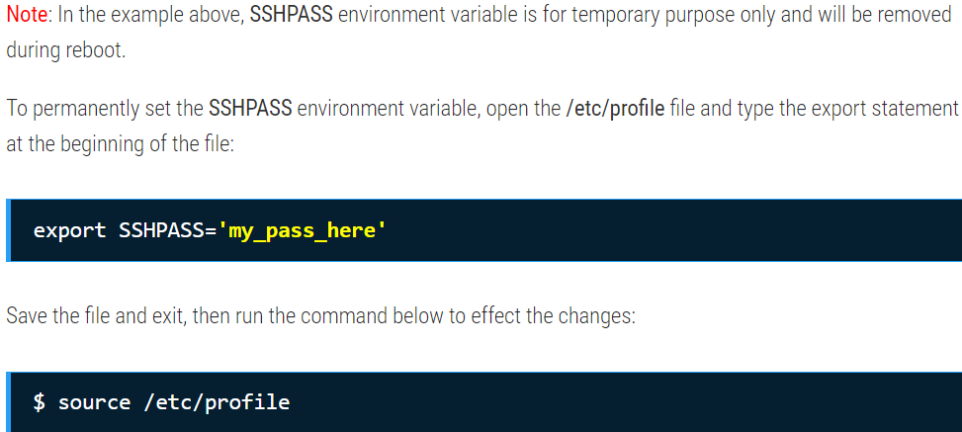

This is how we can pass the password as environment variable using “-e” option in the command

